

**Name: Lester Joel Concessao**

**Course: BSc IT**

**MISIS No.: M00692772**

**ITX2000 COURSEWORK 1 REPORT**

**Name: Lester Joel Concessao**

**MISIS: M00692772**

**Website Name: Sphecs**

**DESCRIPTION**

My website is a phone databasewebsite, that stores specifications and information of phones in the database and lets users post their thoughts on these phones in the comments section. Users must be registered and signed into their accounts to comment in the comment section, unregistered users can use the guestbook feature to post their thoughts on a separate page.

**WIREFRAME**

Homepage

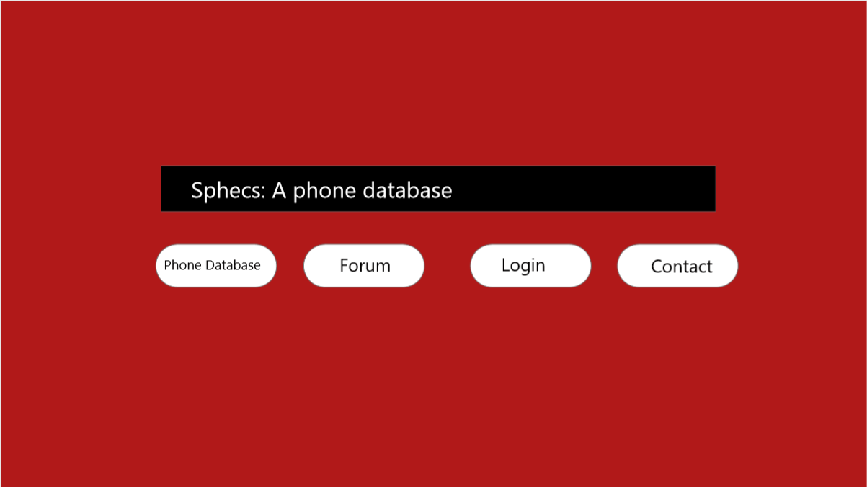

Phone Database Page

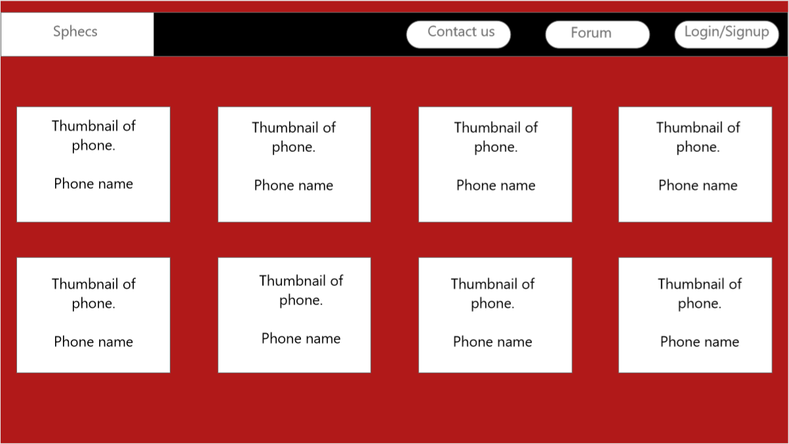

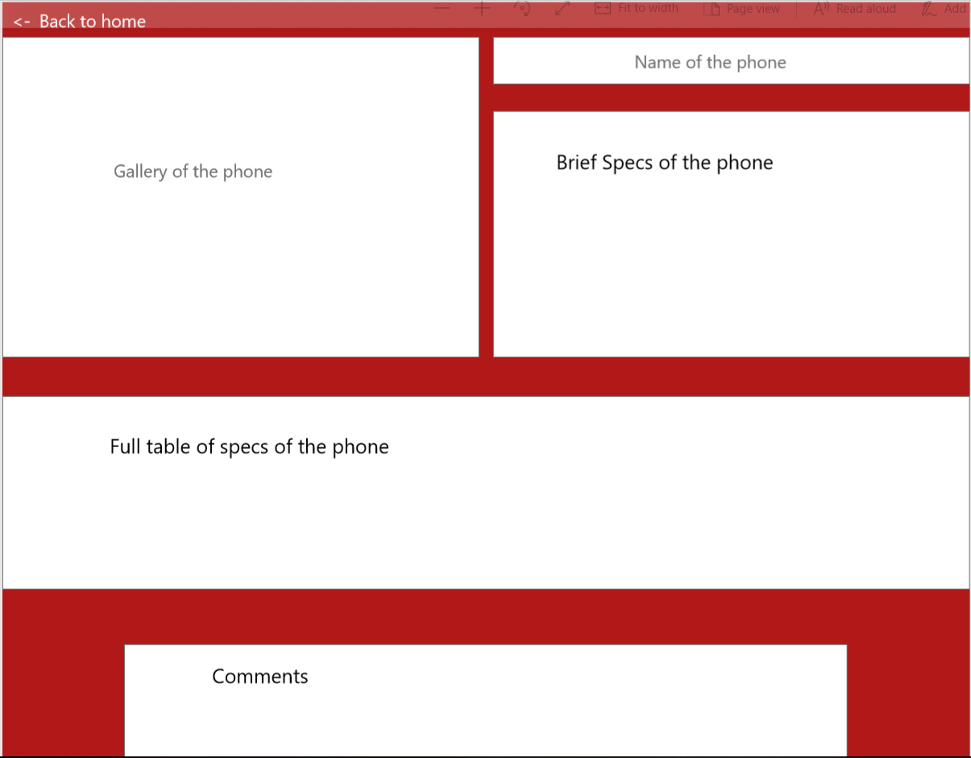

Sign up and Login Page

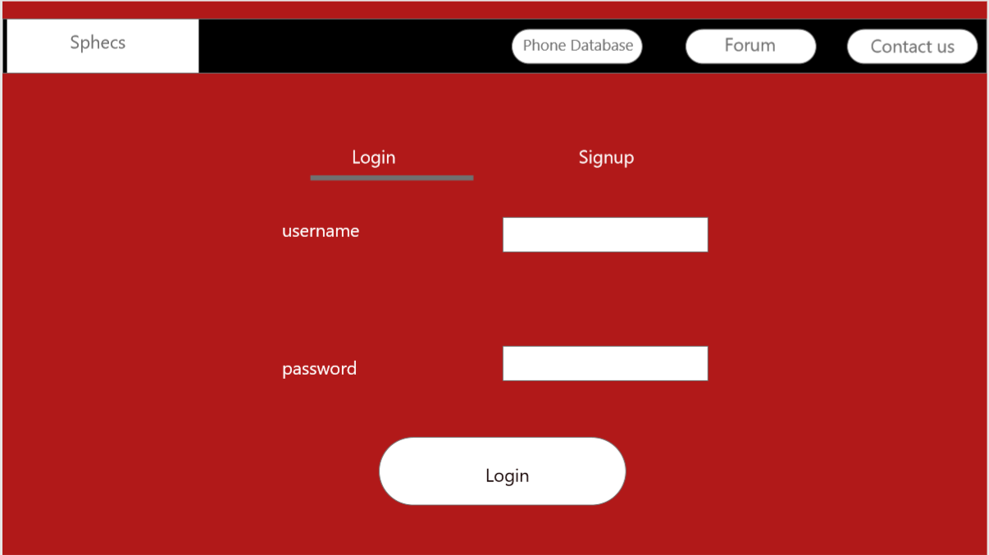

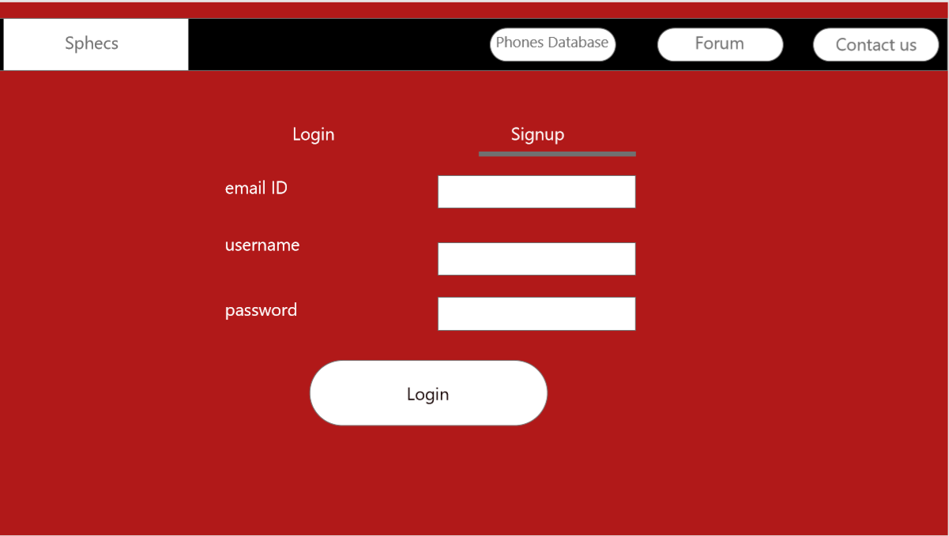

Forum Page

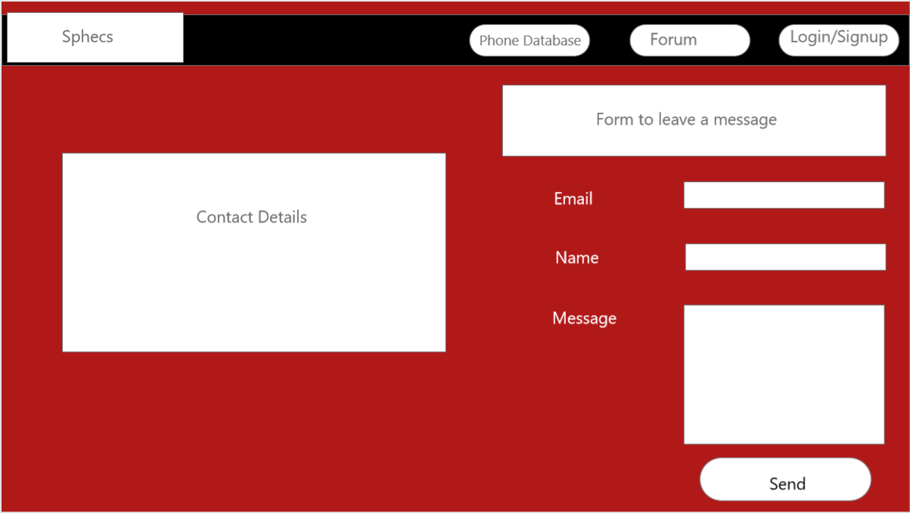

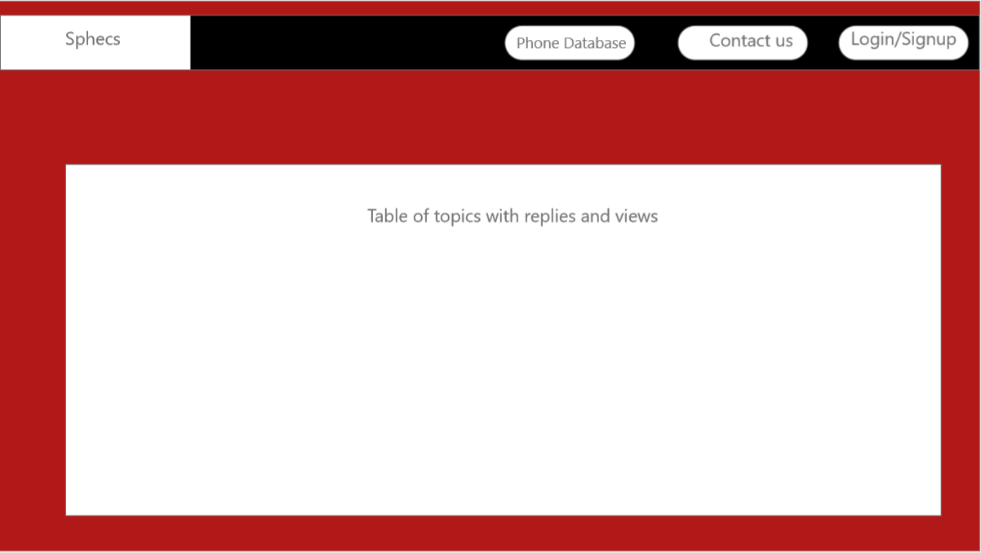

**SCREENSHOTS OF WEBPAGE**

Home Page with search

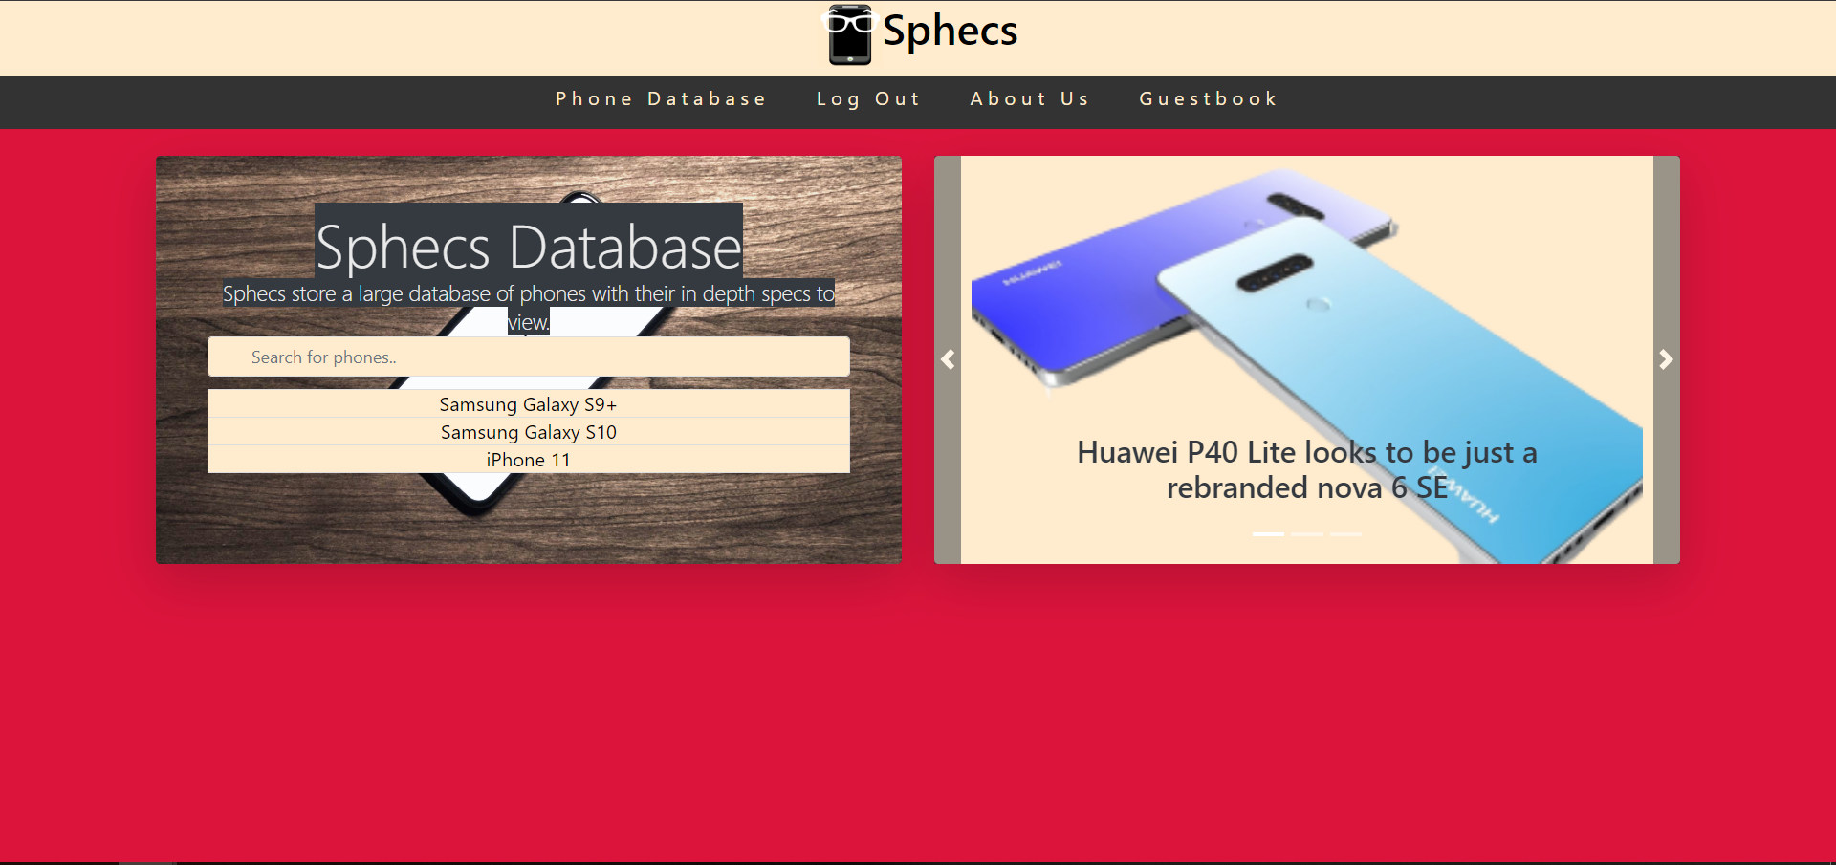

Login Page and Sign up page

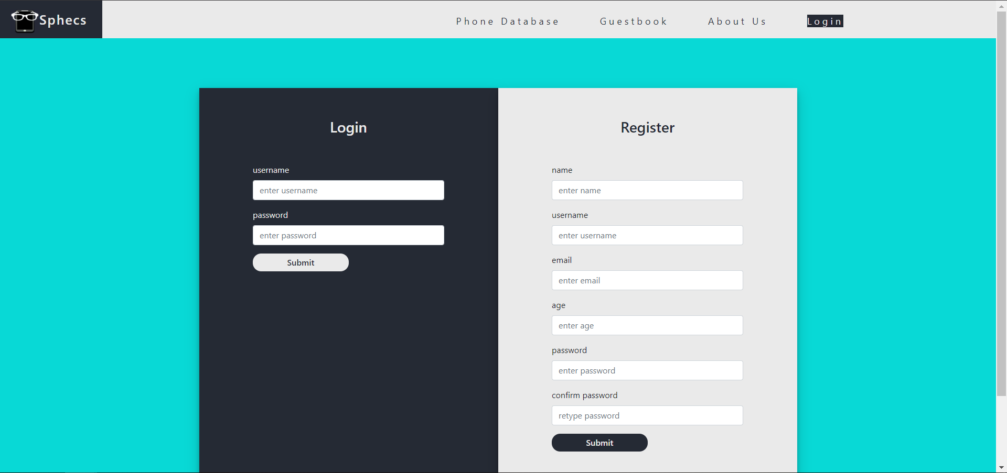

Signed in Successfully page

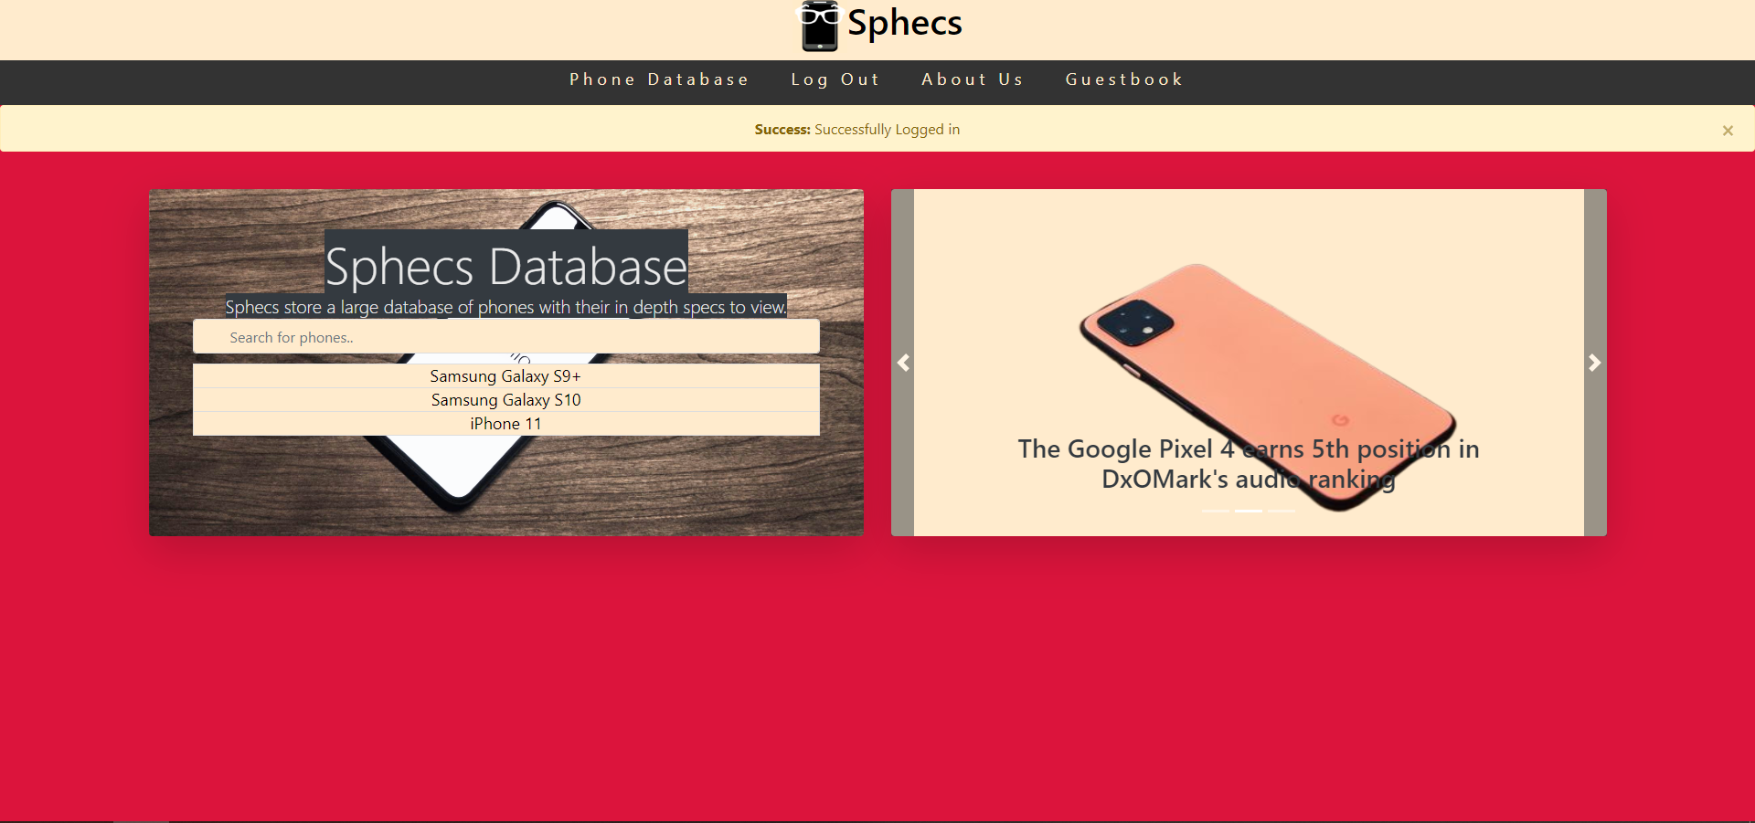

Sign Up Page

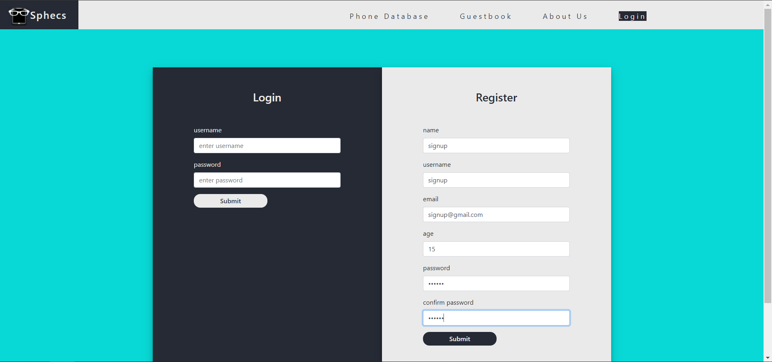

Successful Sign Up Page

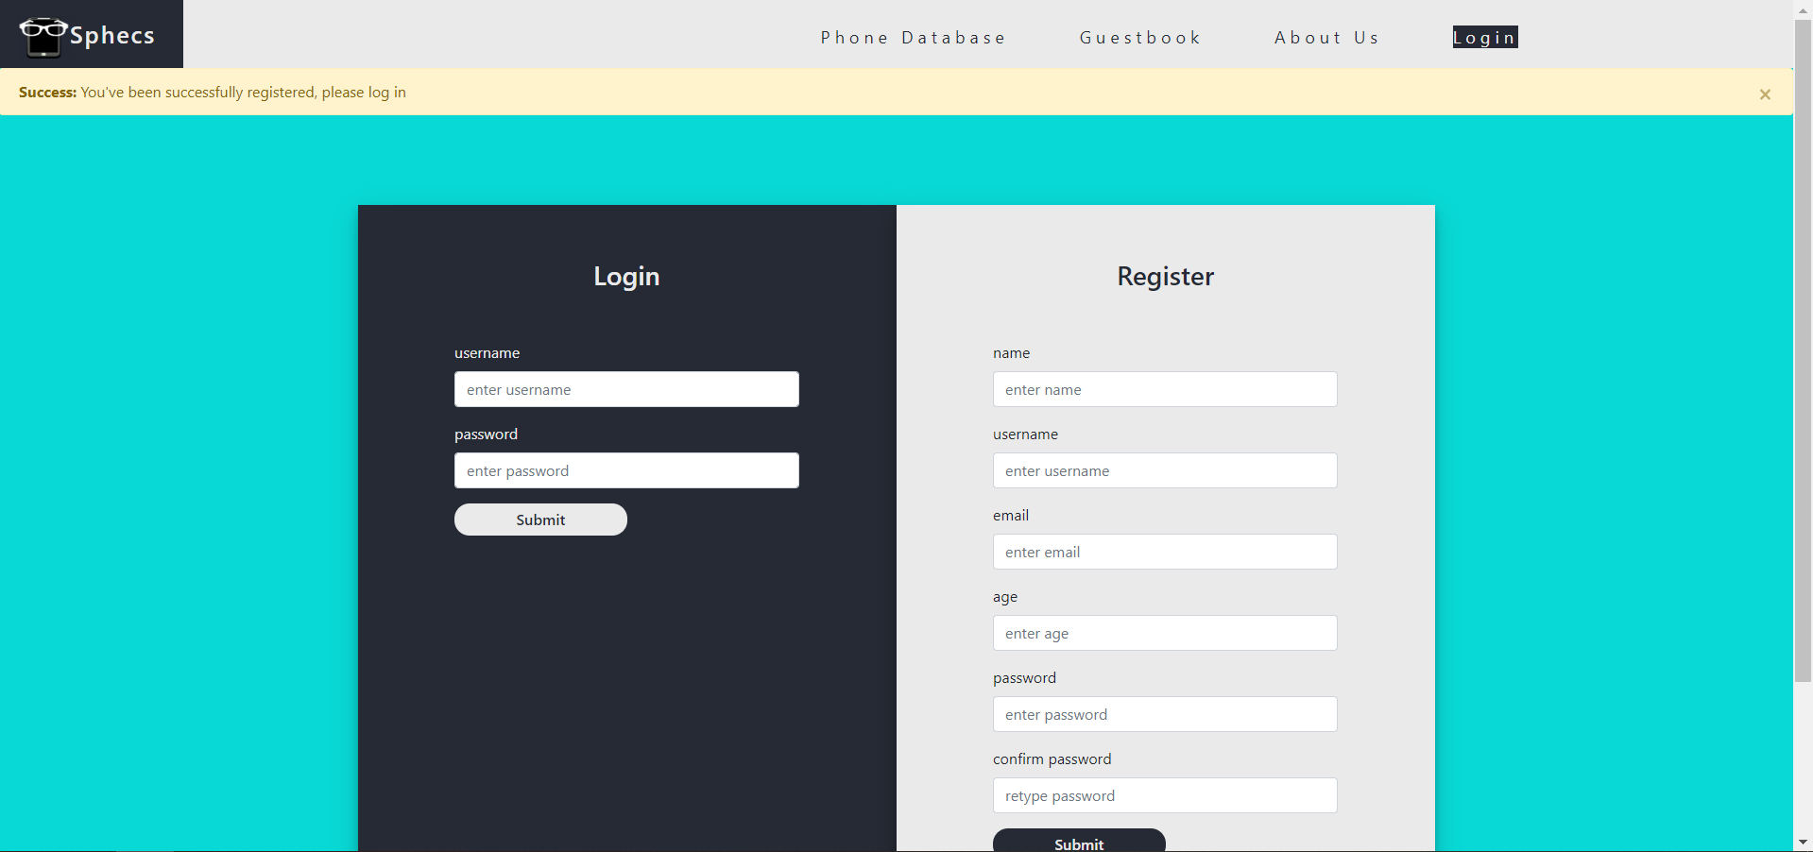

PhoneDatabase Page

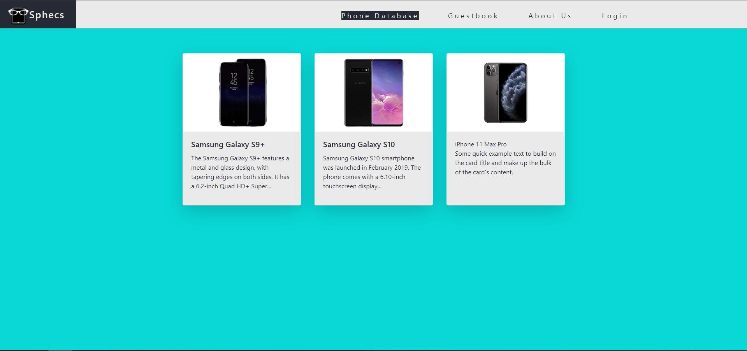

Individual Book Page for a **non-signed in** user

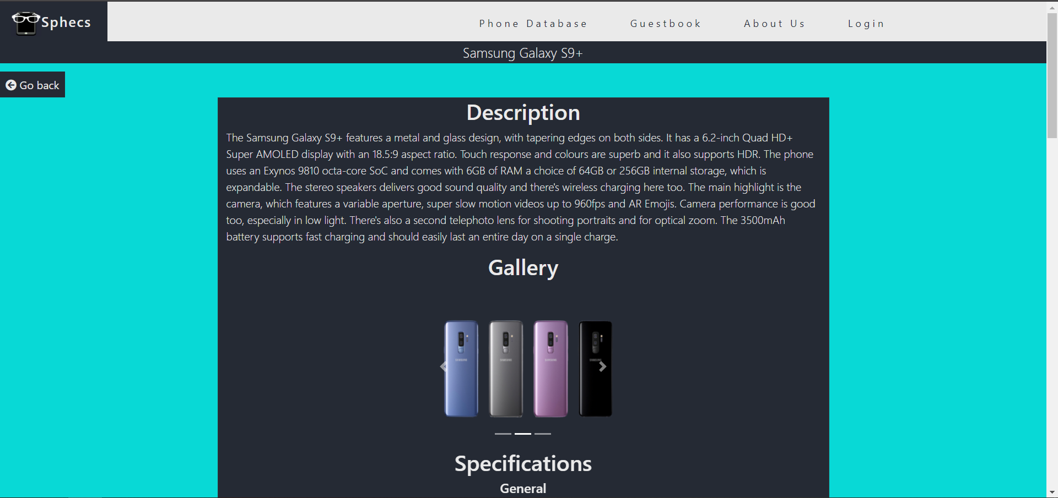

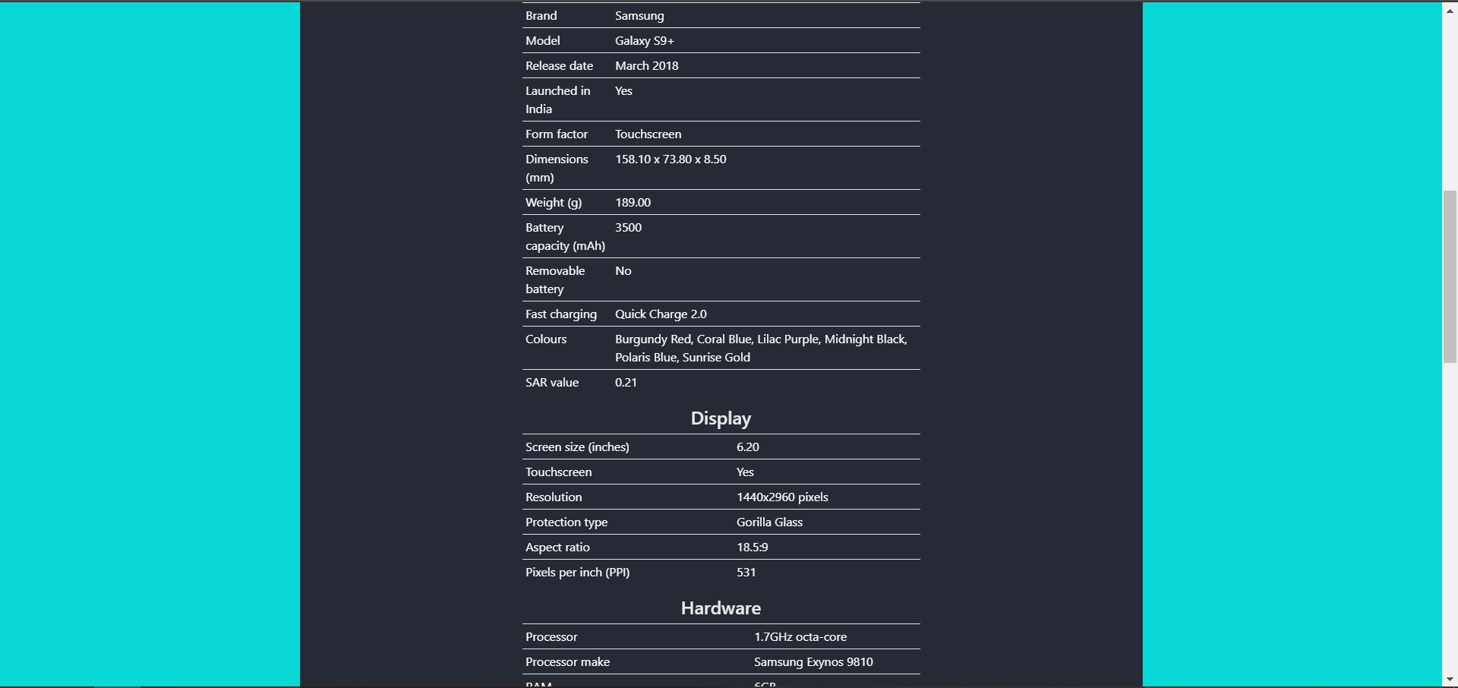

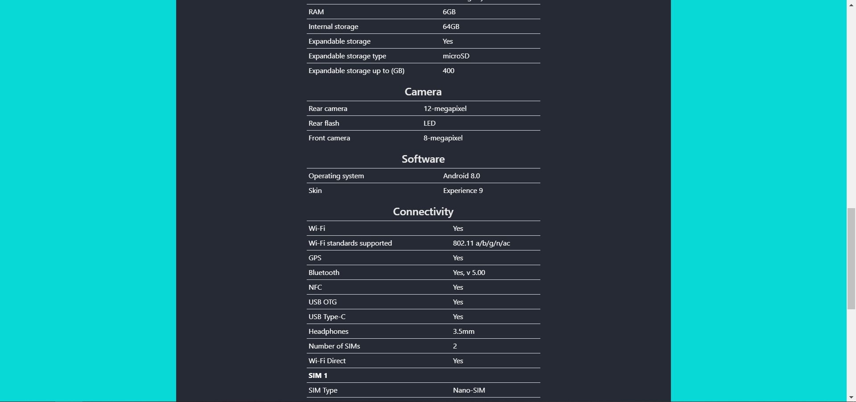

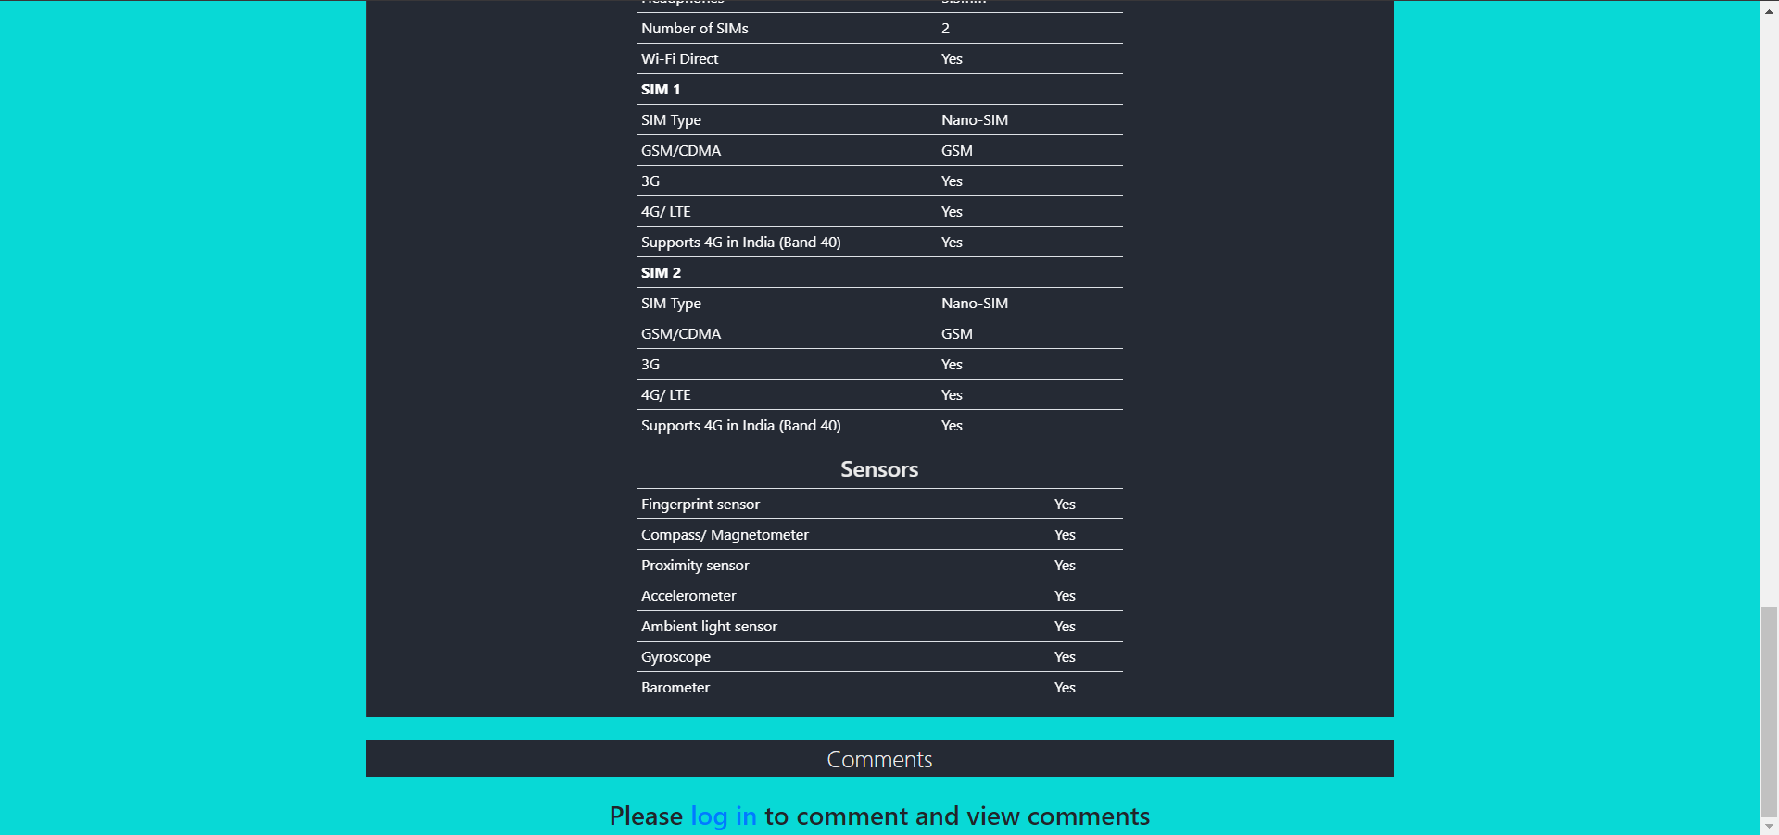

Individual Book Page for a **signed in** user

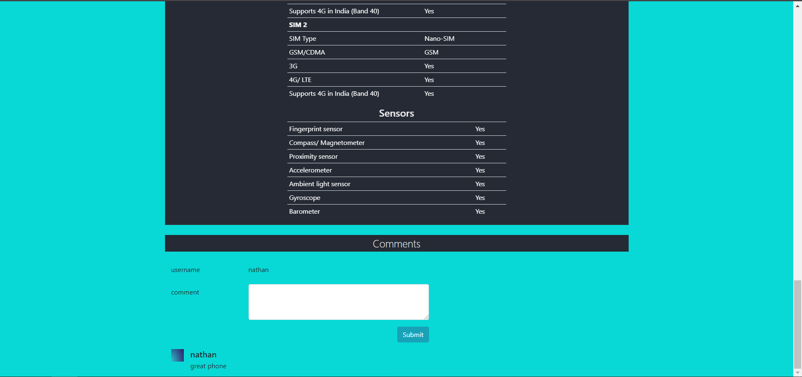

Guestbook Page

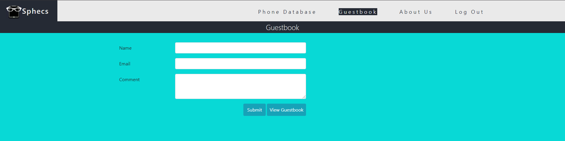

View Guestbook Page

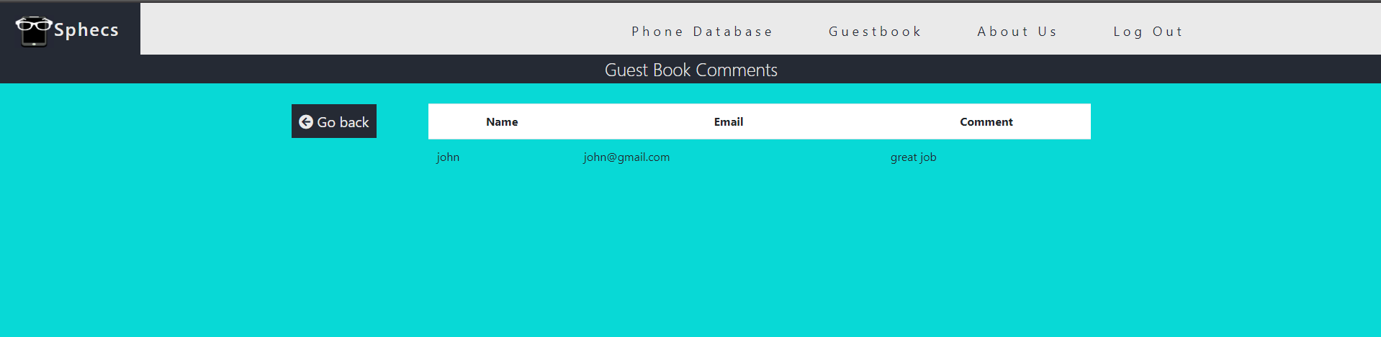

About Us Page

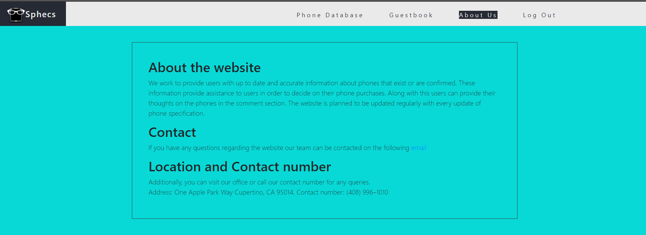

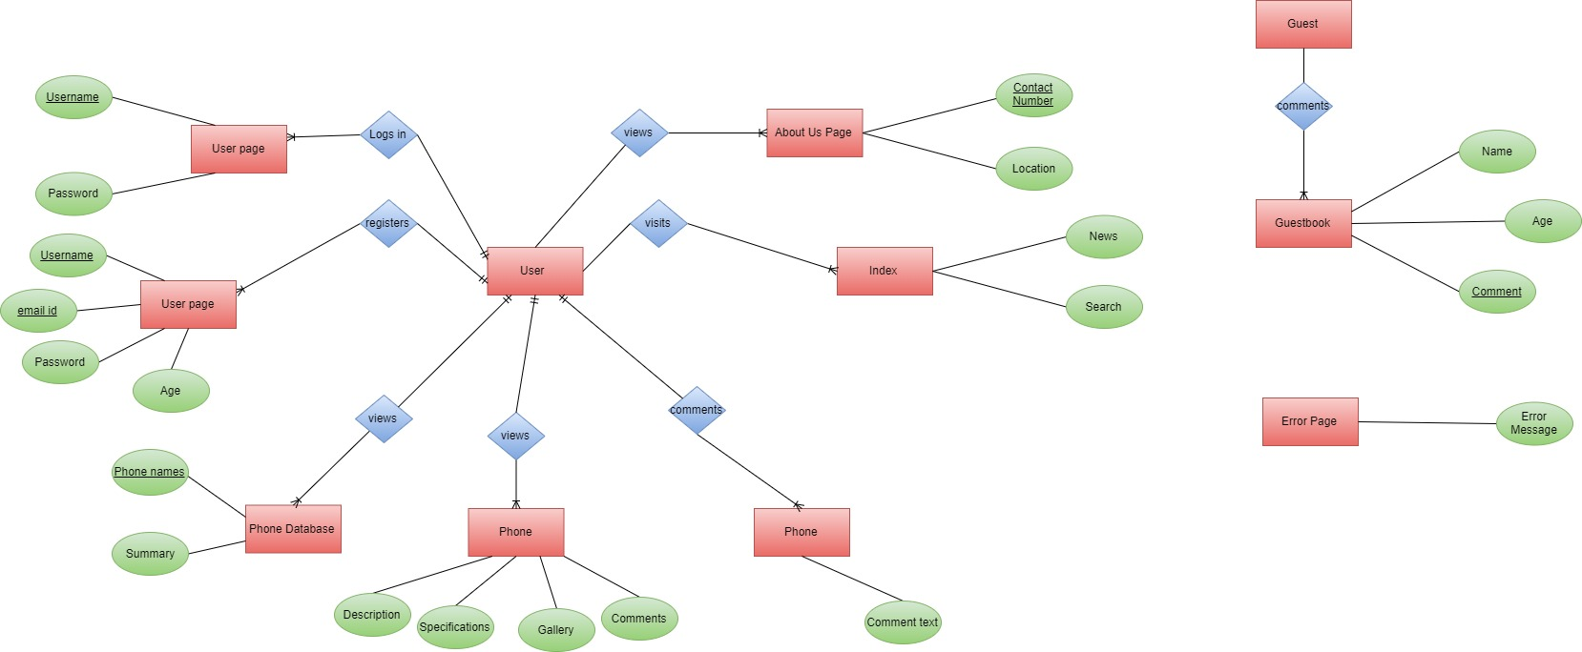**ENTITY RELATIONSHIP DIAGRAM (ERD)**

**WEBSITE SITE MAP**

